Capstone1

Advanced SQL Analysis – Sales & Operations Intelligence (Adventure Works)

1. Introduction
This capstone project focuses on extracting actionable business insights from the Adventure Works dataset using SQL. The analysis covers sales performance, customer behavior, product performance, geographic trends, profitability, returns, seasonality, and customer retention metrics.

2. Dataset Overview
The dataset includes sales data from 2015–2017 along with supporting dimension tables such as products, customers, categories, territories, and returns. Sales data is consolidated using a SQL view for unified analysis.

3. Tools & Technologies
• MySQL
• MySQL Workbench
• SQL (Joins, Subqueries, Aggregations)
• Adventure Works Dataset

4. Annual Revenue Trends
Revenue was calculated by multiplying order quantity with product price. Year-wise analysis revealed growth patterns and peak-performing years.

5. Category Performance
Product categories were ranked based on total revenue and units sold, highlighting high-performing and low-performing categories.

6. Product Performance
Top and underperforming products were identified using total revenue and quantity sold, aiding inventory and marketing decisions.

7. Geographic Sales Leadership
Sales performance was analyzed across regions, countries, and continents to identify top-performing markets.

8. Profitability by Territory
Profit and profit margin were derived using product price and cost, helping identify high-margin territories.

9. Return Analysis
Return rates were calculated by comparing returned quantities against sold quantities to detect quality or expectation issues.

10. Sales Seasonality
Monthly and yearly seasonality analysis helped identify demand peaks and low-sales periods.

11. New vs Returning Customers
Customers were classified based on first purchase date to compare revenue contribution from new and repeat customers.

12. Key Business Insights
• Revenue growth is driven mainly by returning customers
• Certain categories and regions consistently outperform others
• High return rates indicate improvement areas
• Seasonal trends can guide marketing and inventory planning

13. Conclusion
This project demonstrates how SQL can be effectively used for end-to-end business analysis. The insights derived can support strategic decision-making in sales, operations, and customer management.

Q1Annual Revenue Trends:

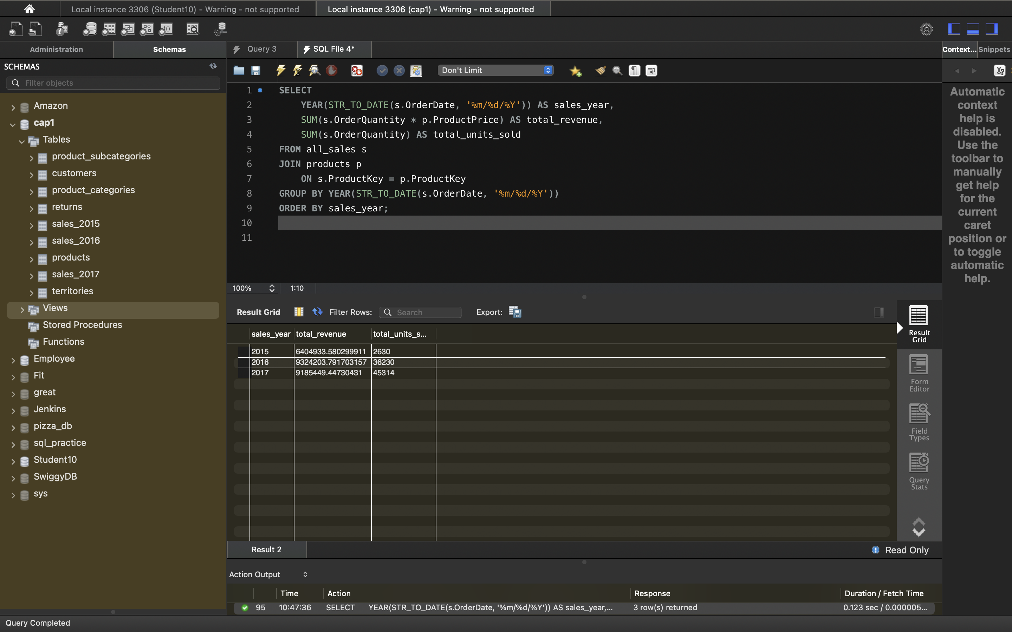
The sales tables did not contain a direct sales amount or revenue field. Therefore, total revenue was derived by multiplying order quantity with the product list price obtained from the product master table. This approach mirrors real-world transactional systems where revenue is calculated at query time.

Q2Category Performance:

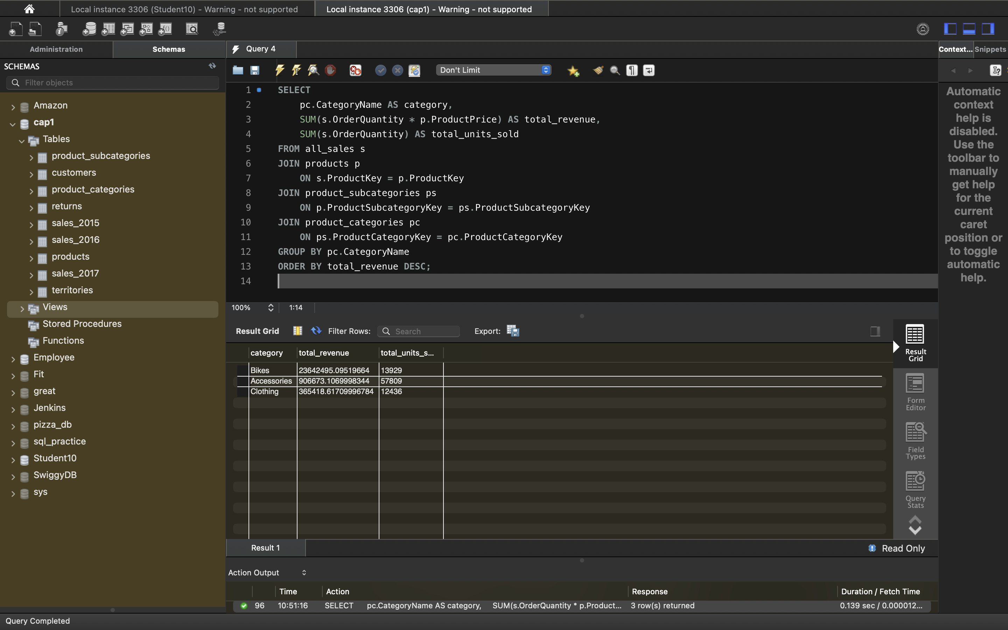
The Bikes category generated the highest revenue, indicating strong demand and premium pricing. Accessories and Clothing showed comparatively lower revenue, suggesting opportunities for bundling, promotions, or pricing optimization. Category-level analysis helps the business prioritize inventory and marketing investments.

